- 注意。注意。注意。更新双系统后模拟器读取ROM入径已经发生变化，需要根据说明进行更新操作 Attention!!! After updating the dual system, the simulator reads the ROM path has changed and needs to be updated according to the instructions.
- 第一步把64GB旧系统卡格式化 The first step is to format the 64GB old system card.
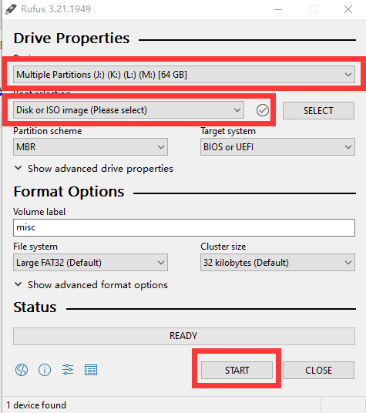
- 烧录双系统img镜像 Burning of the dual-system img image
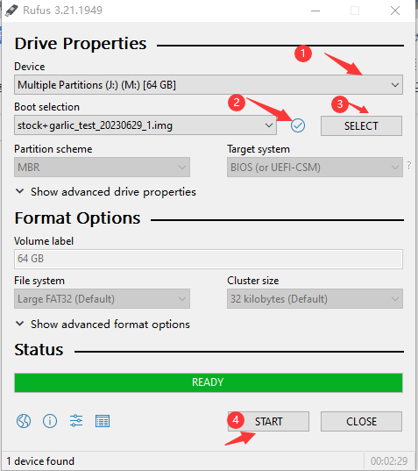

- 用DiskGenius.exe工具扩容，在第4 盘符点击右键扩容 To resize using the DiskGenius.exe tool and right-click on the fourth drive to expand capacity.
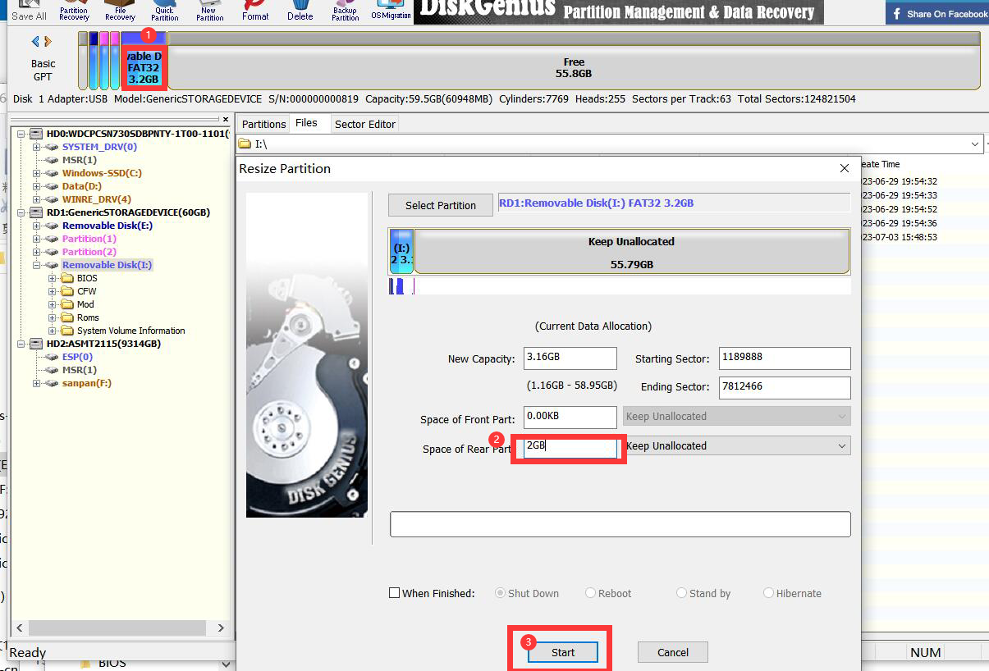
- 关掉DiskGenius在电脑端弹出可用U盘以最大容量为准，将下载后的game包解压拷贝到ROM文件夹中，这个是模拟器需要读取的入径 Close DiskGenius and choose a drive with the maximum available capacity that pops up on the computer. Extract the downloaded game package and copy it to the ROM folder. This is the path that the emulator needs to read.
